**35.AWS-IAM-Users-Groups-Roles-Polocies-CrossAccountRols-**

**ADCreation**

--- **Roles** – one AWS service needs to access other AWS service and where you don’t want to use access and secret key.

**Users**

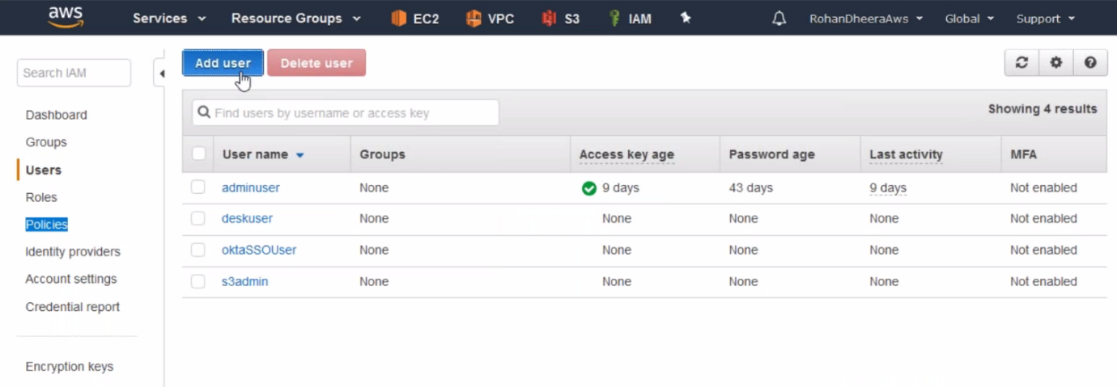

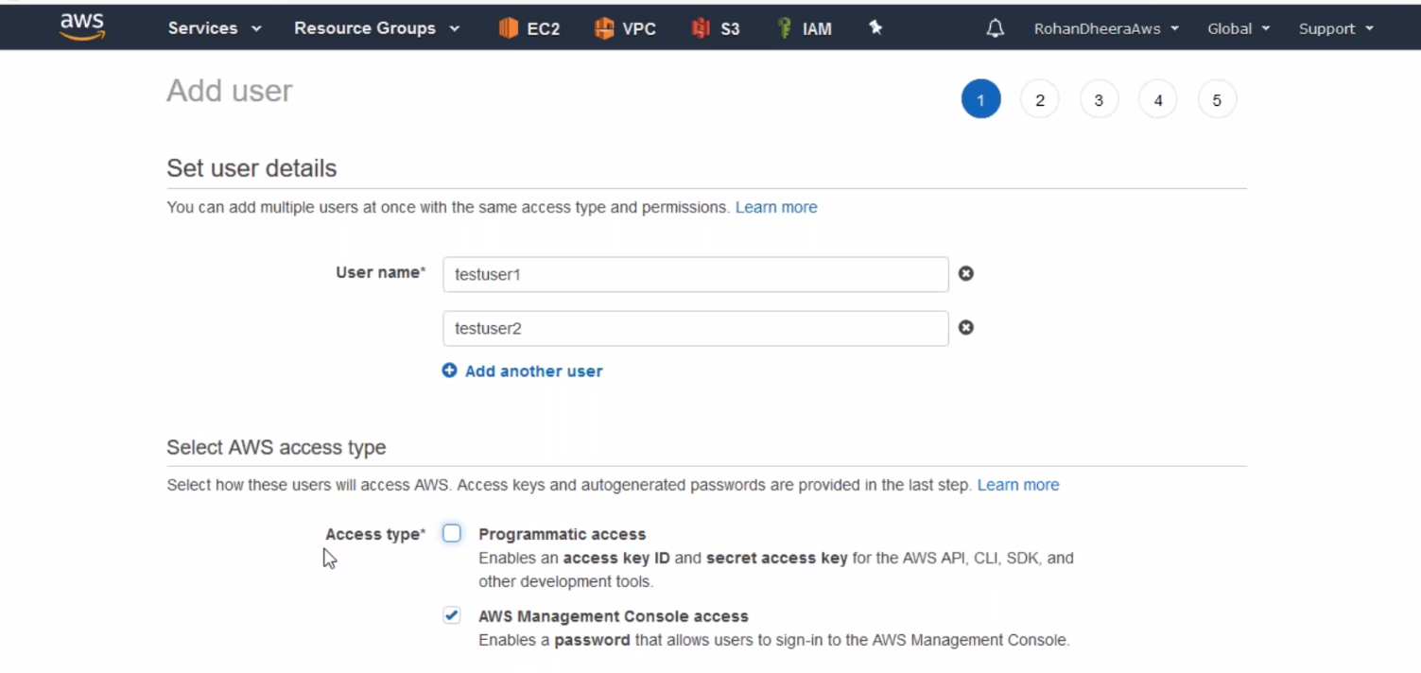

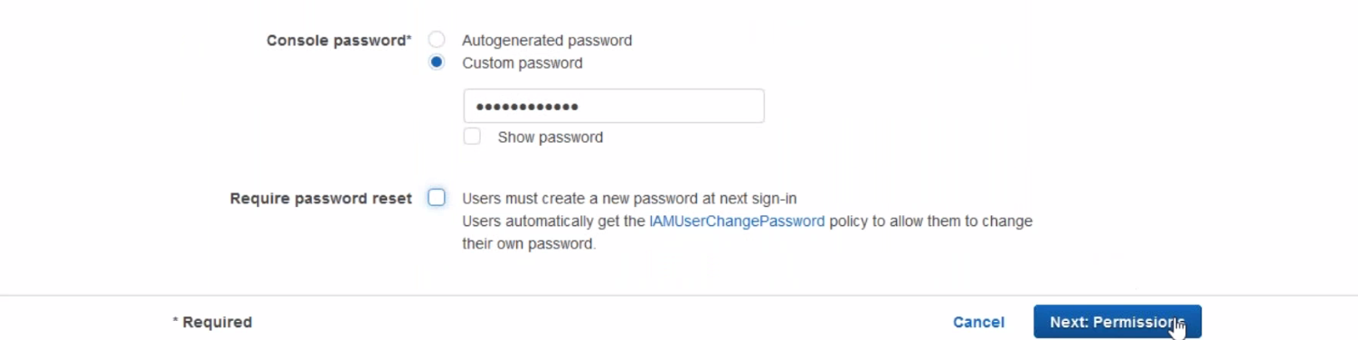

--- here we can add multiple users, if you check the require password reset then user needs to reset the password. 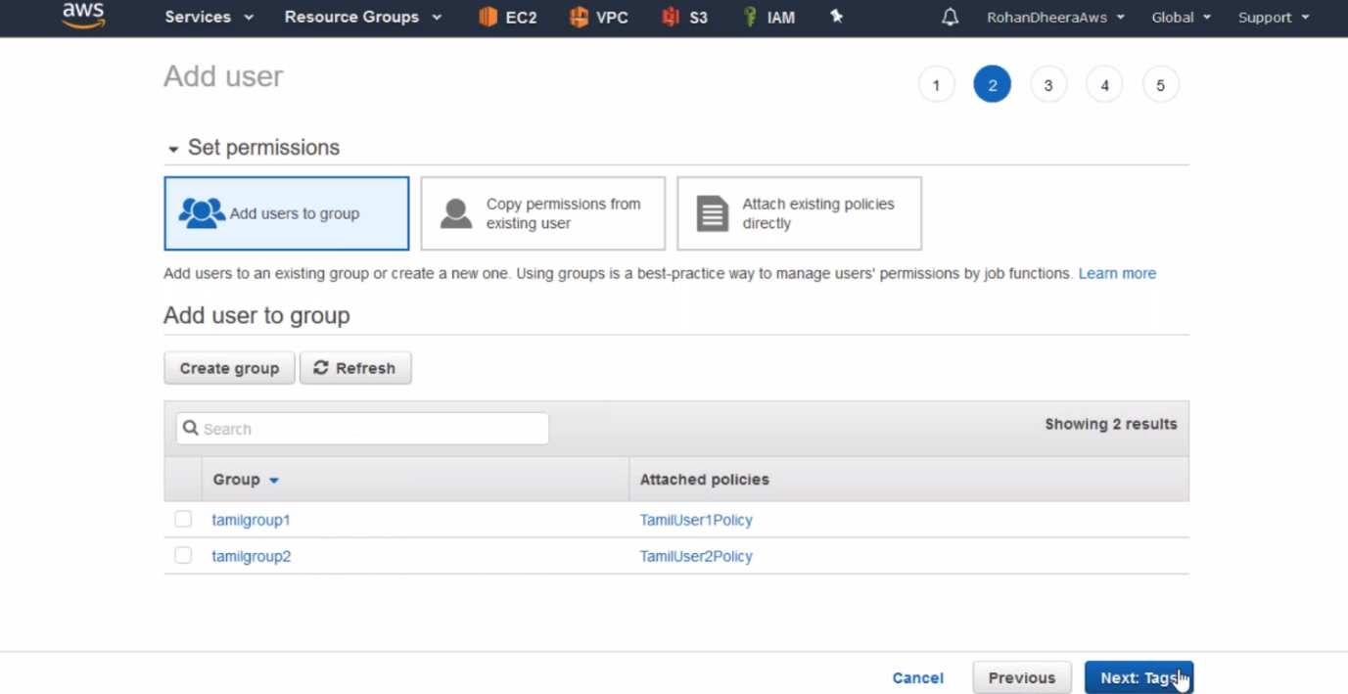

--- by default, user don’t have any permission we need to add permission by giving policy.

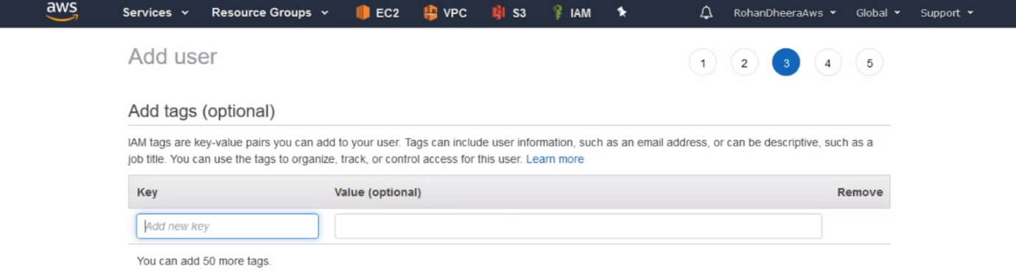

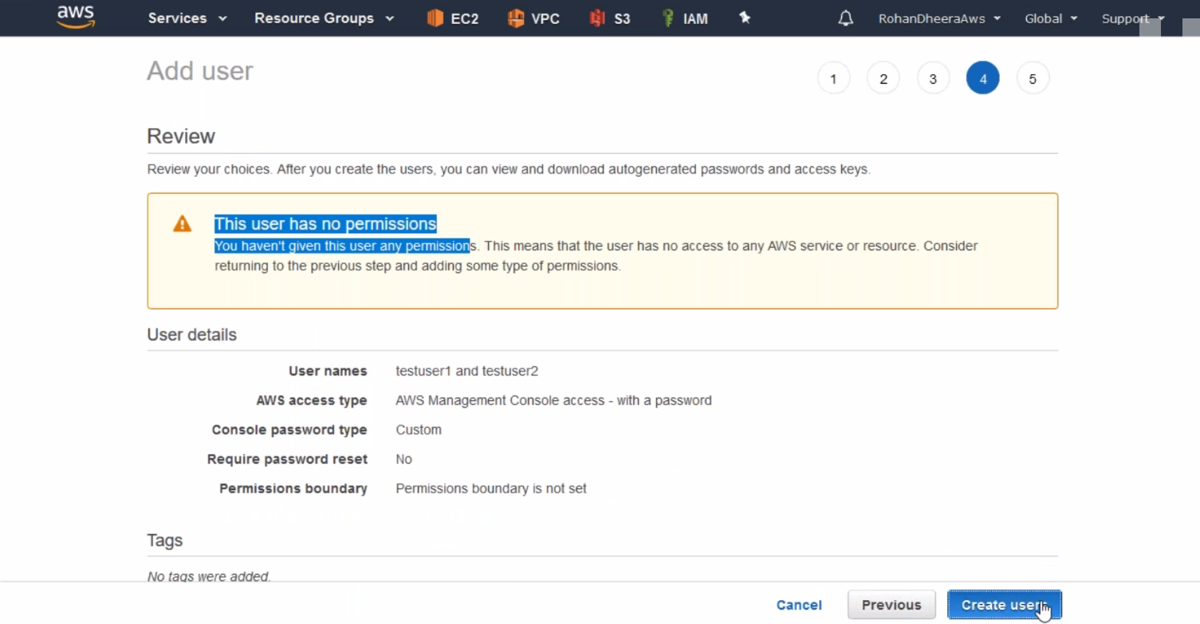

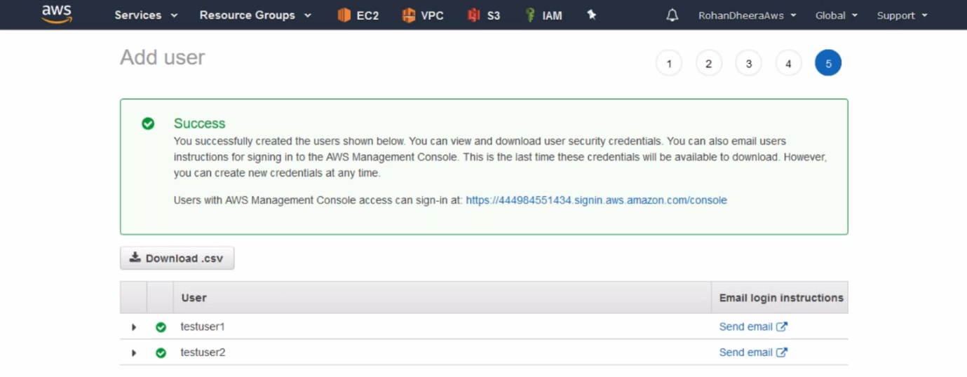

--- here 2 have created.

--- copy the above link for user login.



--- we can change the link id by going to dashboard and click on customize.

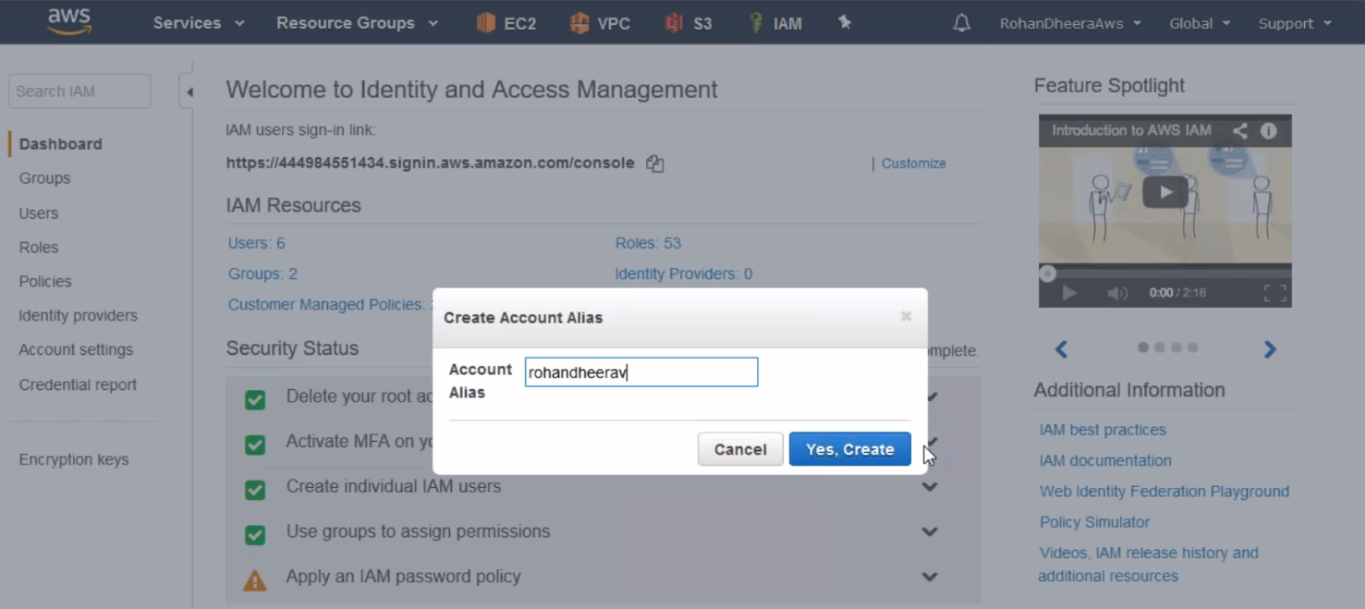

**User login**

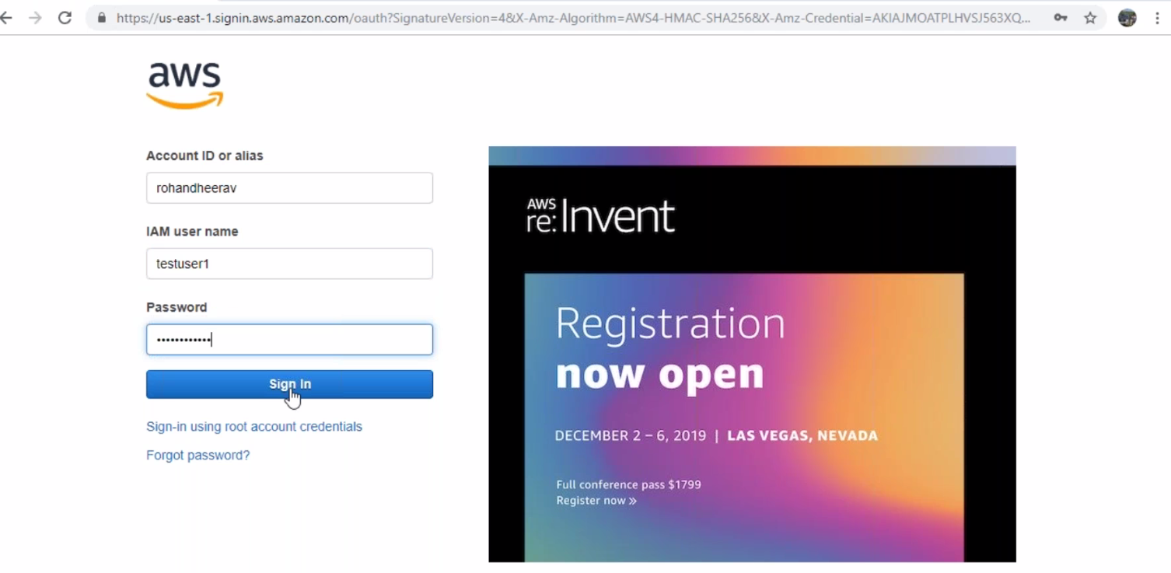

--- when you create users by default, he don’t have any access. We will give access.

**Groups**

in your company you have more no of contractor workers. They will only work for short time in this case you have create users and give permission for every user. Instead of creating every time we will create group and we will add users to the group and there we will add permission to the group

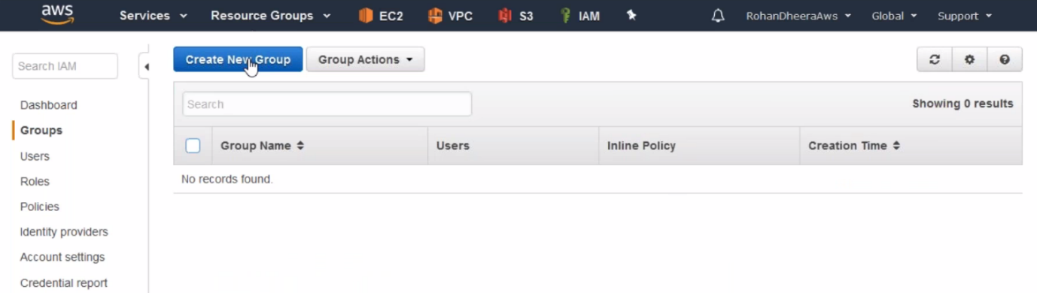

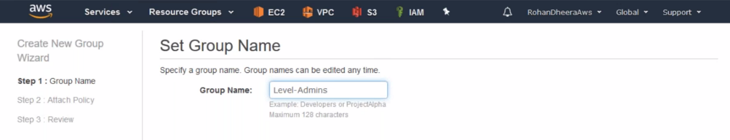

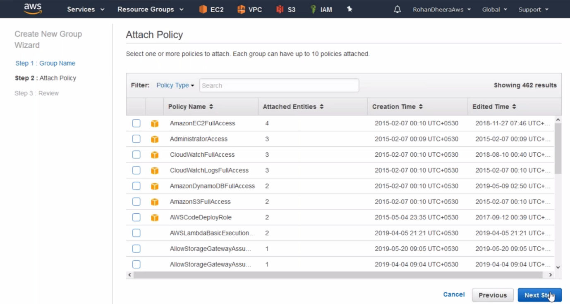

--- you find orange cube in the policy it means these are AWS default policies.

--- with out orange policy are user created policy.

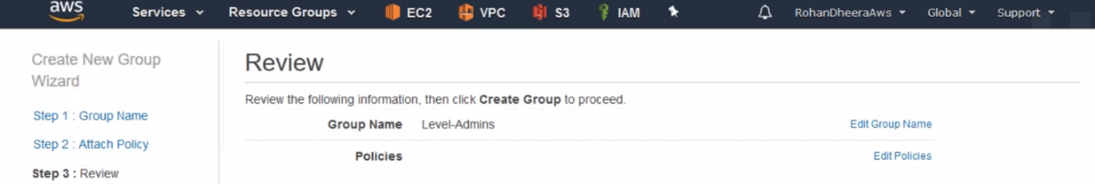

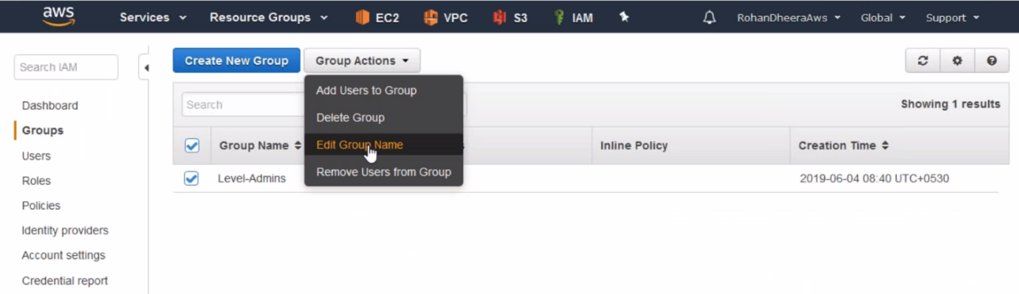

**Edit group name**

you want to eddit already created group name.

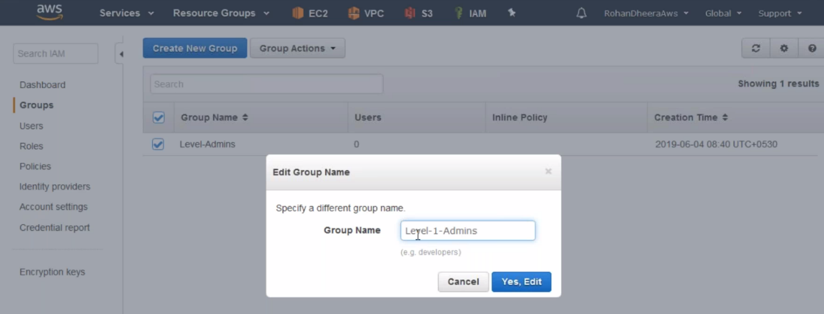

--- level-1-Admins have read only access permission’s

**Attach policy to the group**

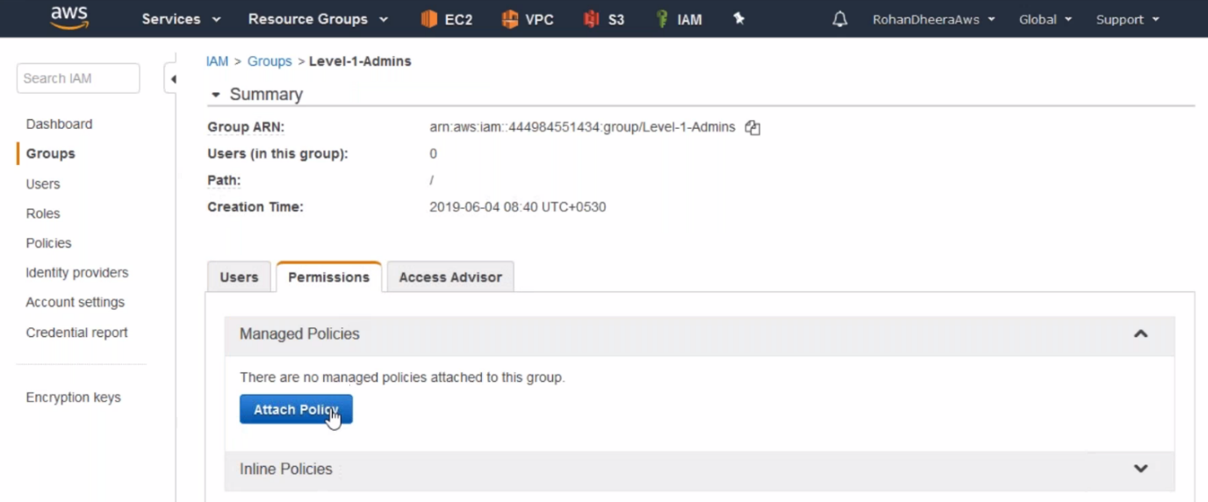

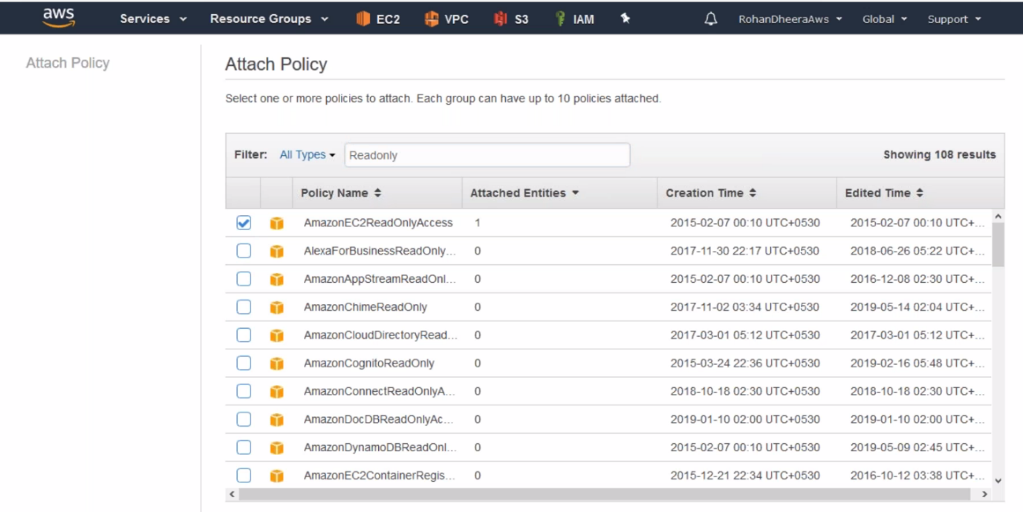

**Adding users to the group**

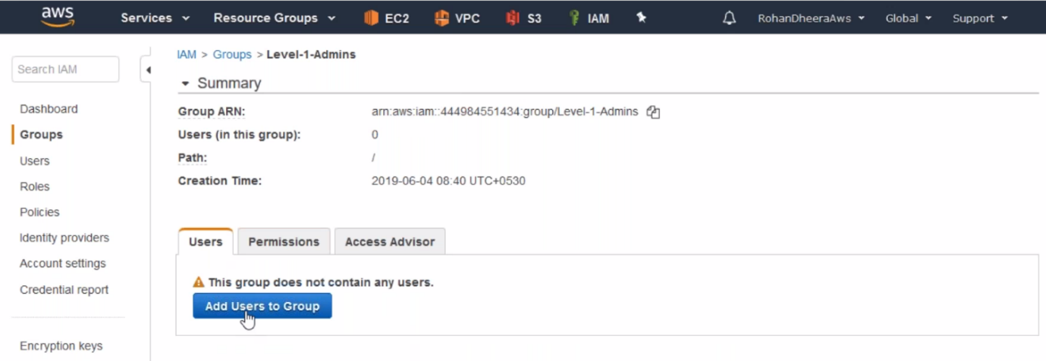

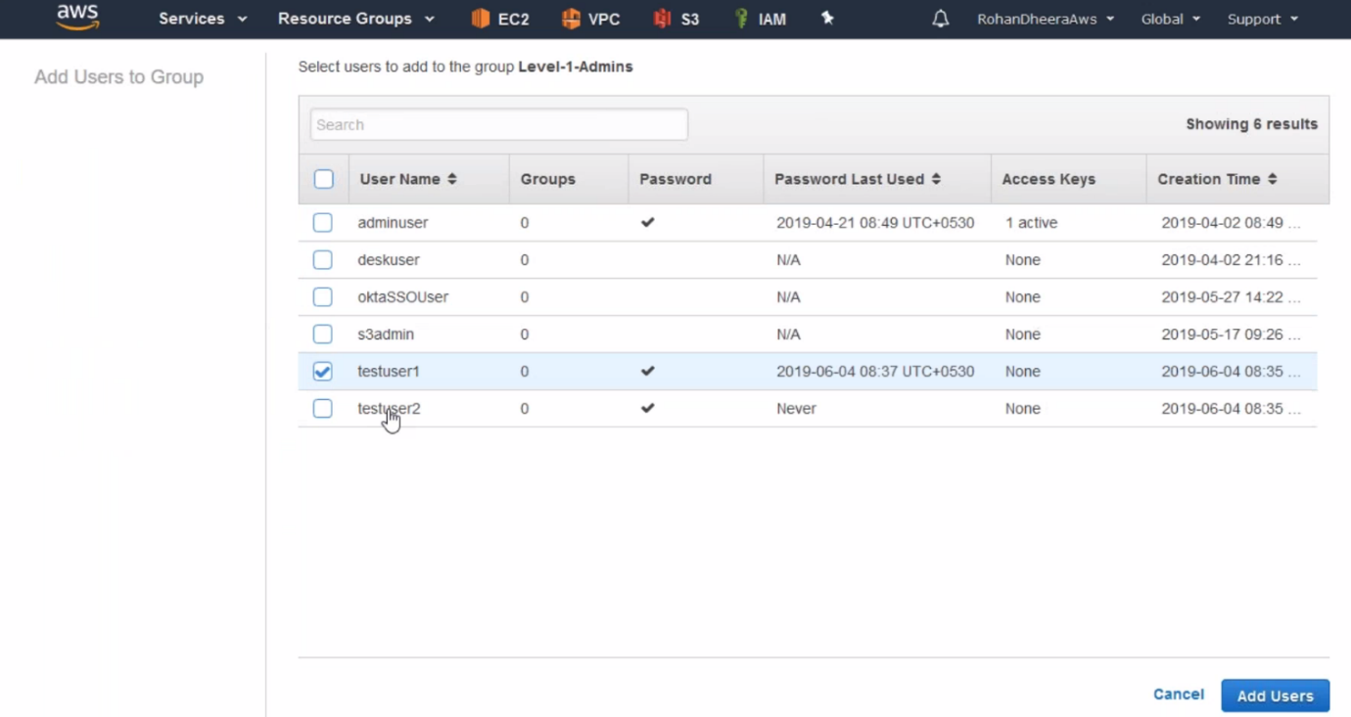

**Customization policy creating**

Here we use tags for applying permission to prod server or Dev server.

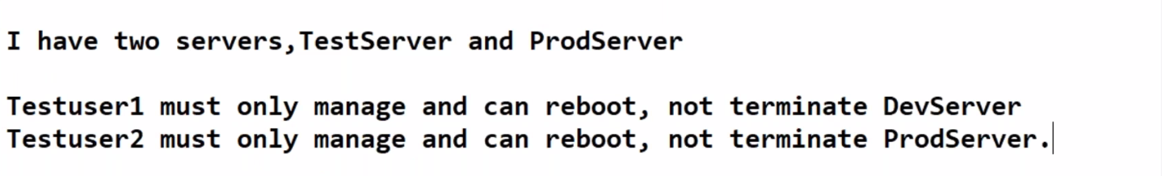

--- restrict AWS user EC2 instance – type this on google for below.

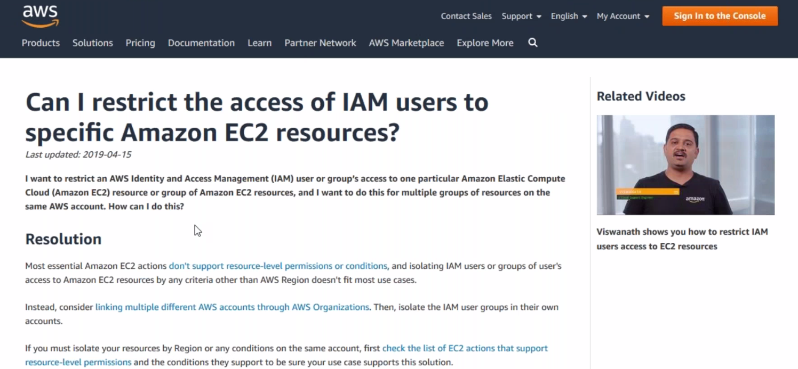

--- policy for IAM user to see EC2 instance.

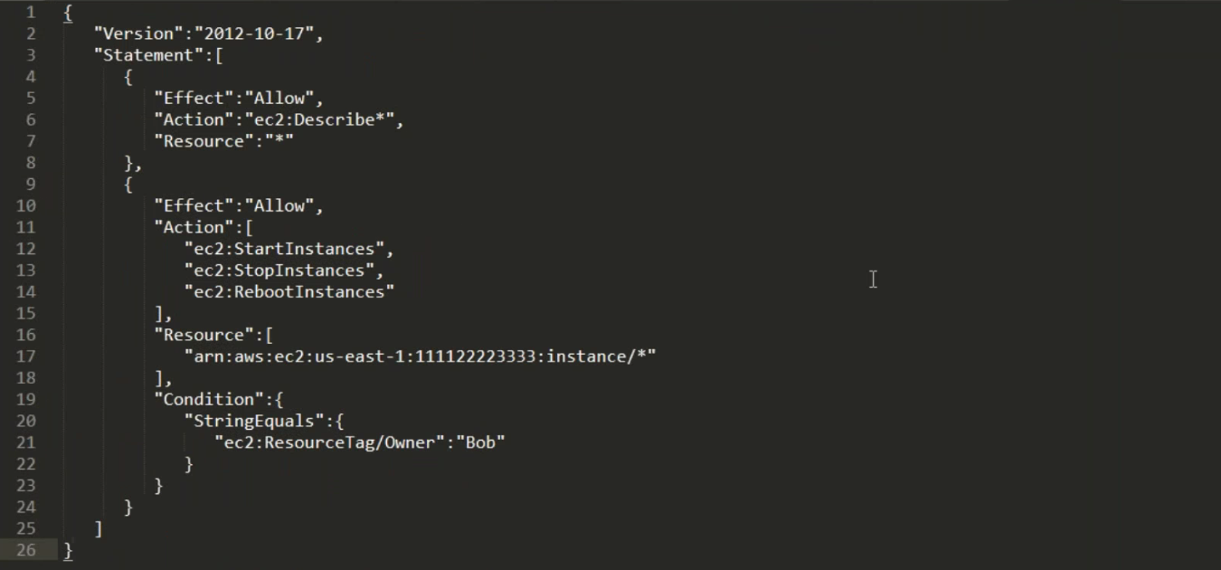

**For test server policy**

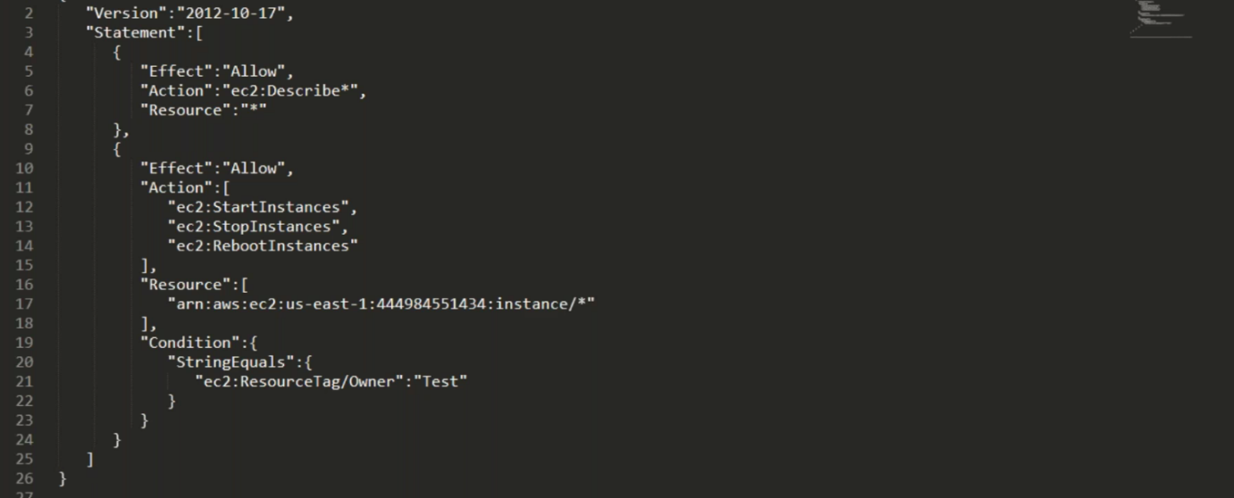

--- give AWS account id and instance tag so the instance will assign to particular user only.

**For prod server policy**

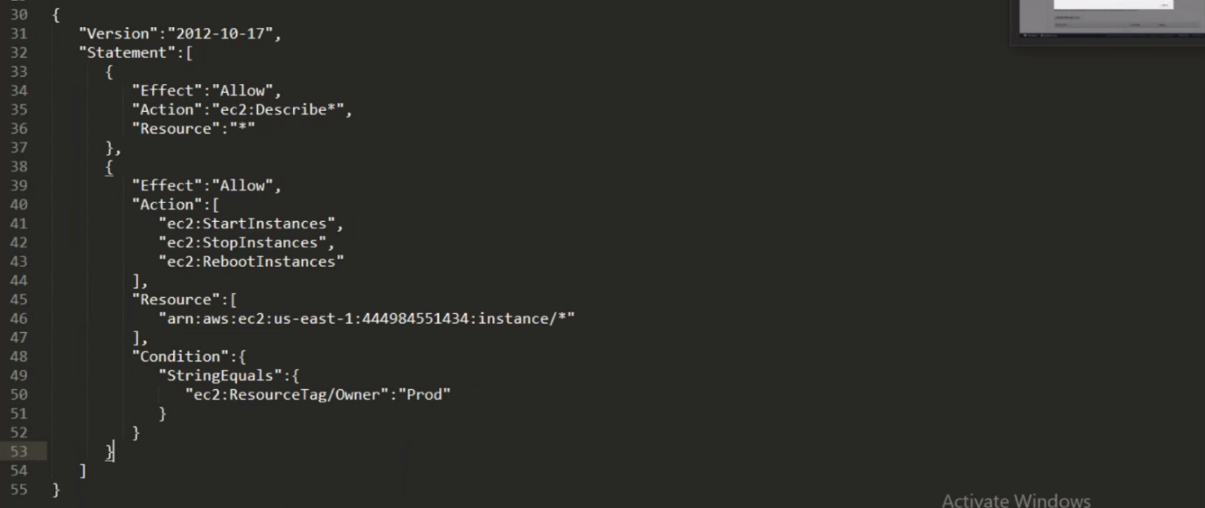

--- in the EC2 instance add tags like Owner = Prod

--- now the policies are ready and we have to create policies and assign them to users.

**Policy creating**

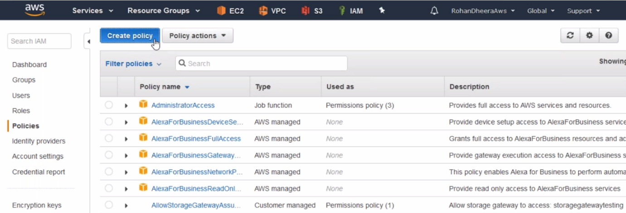

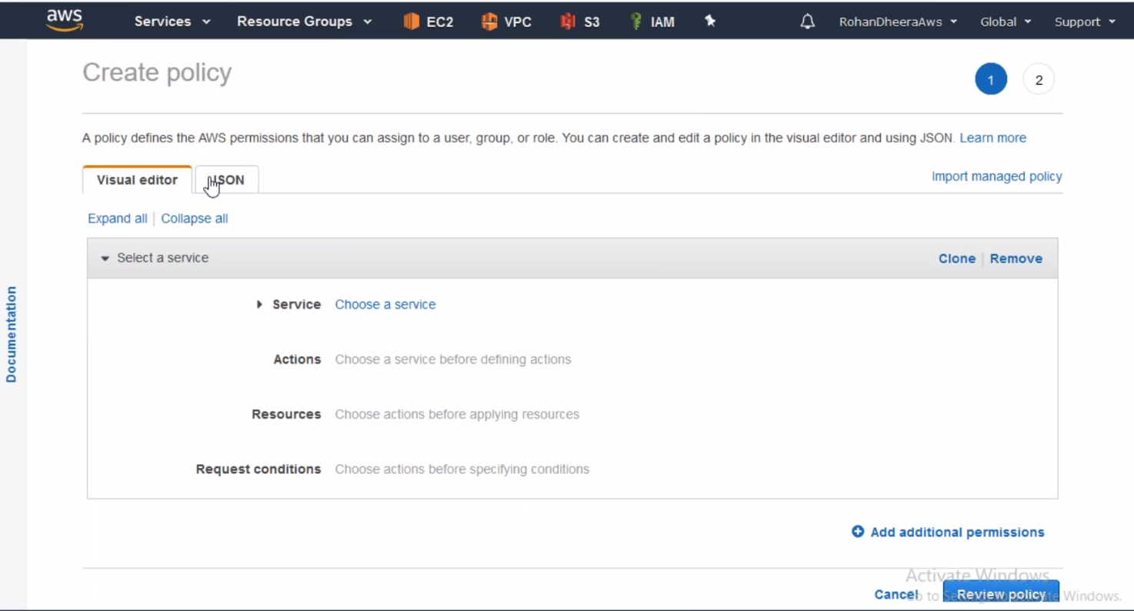

--- click on JSON.

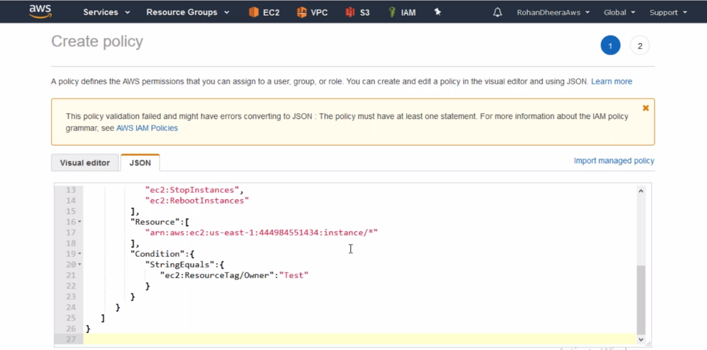

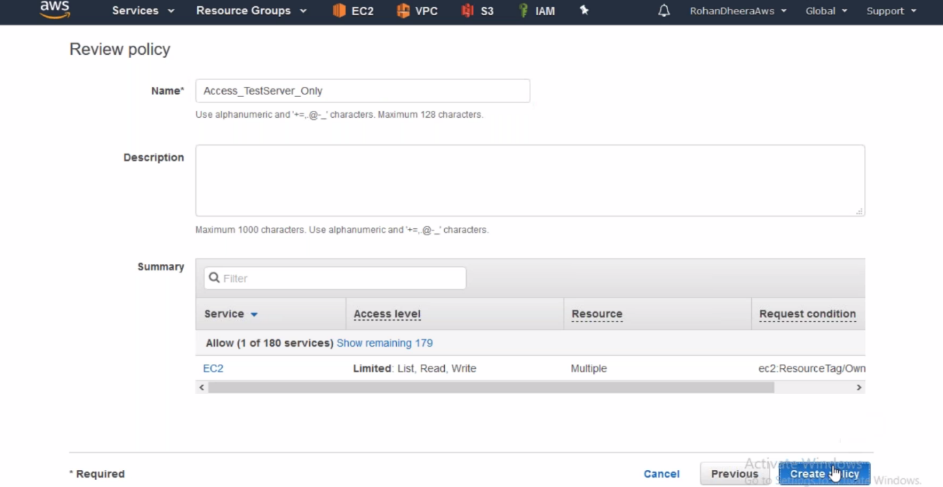

--- I just created policy for test servers.

**Roles**

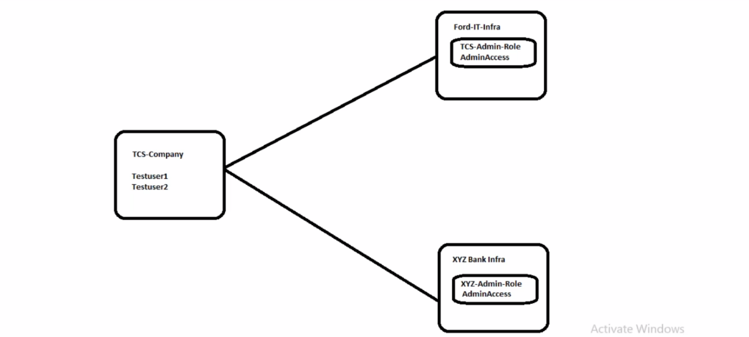

Here TCS is maintaining the ford and XYZ bank infra. From TCS company there are two users are accessing the infra and maintaining using Roles.

--- for easy understanding this concept

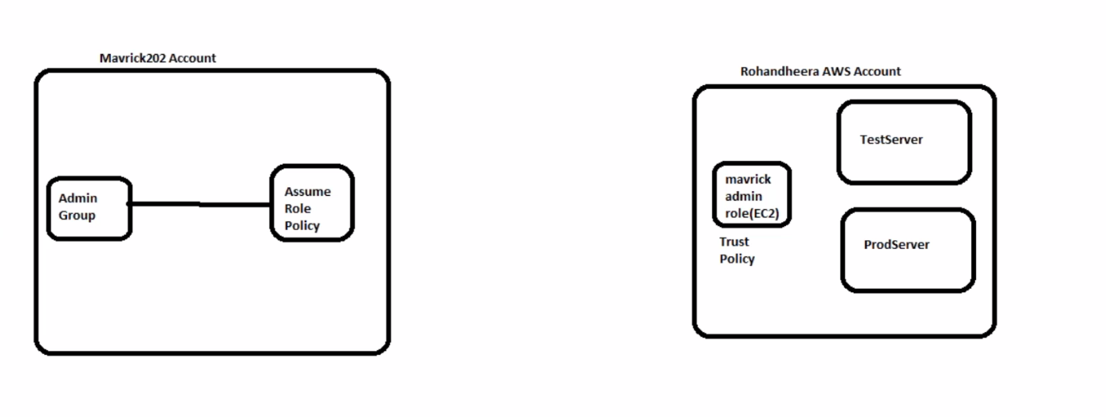

Here we have 2 AWS accounts. In Rohandheera AWS account we have test and pord servers. We need to access these servers from mavric202 AWS account. For accessing these servers we need to allow mavric users only.

You want to allow mavric202 users to accessing test and prod servers. You have to create Role and trust policy in Rohandheera AWS account and also we need to create another policy in mavric account. Here the trust policy have the details of mavric users. And assume role policy in mavric202 have details the rohandheera Role details.

**Mavric202 AWS account**

--- here go to the IAM and create a Group and user then add user to the Group.

--- create policy and attach the policy to the group.

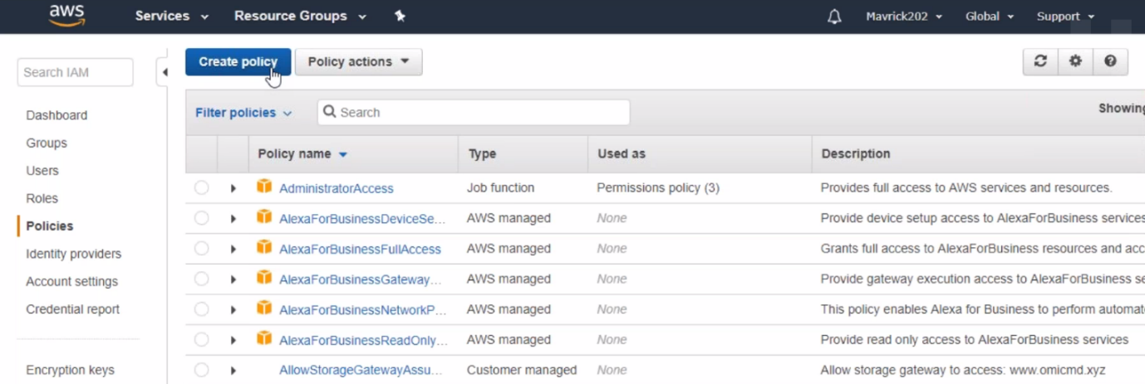

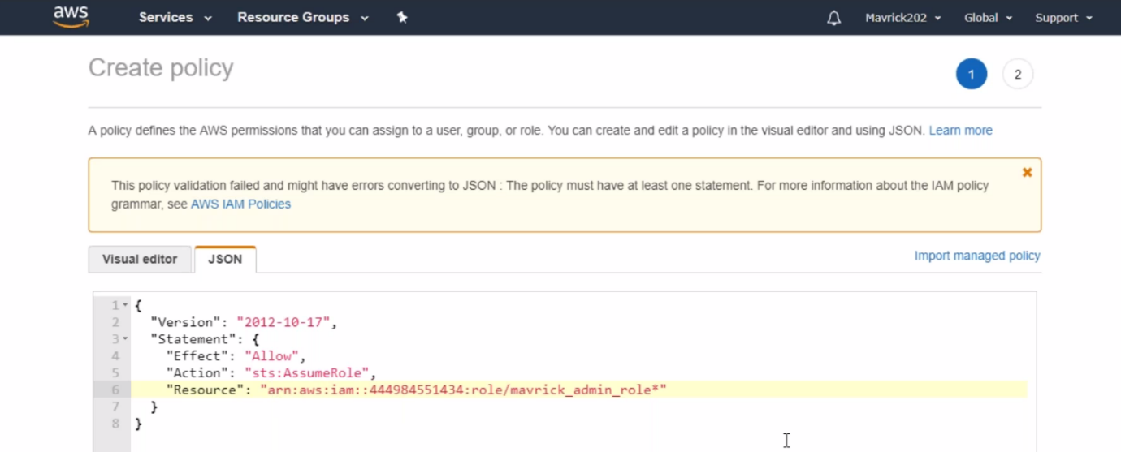

--- paste the coped ARN here. Now these users only Allowed to managed other AWS account servers.

--- if you have 2 different environments to manage form one AWS account then delete AWS account id give * and also the policy ARN should present in that 2 different environments.

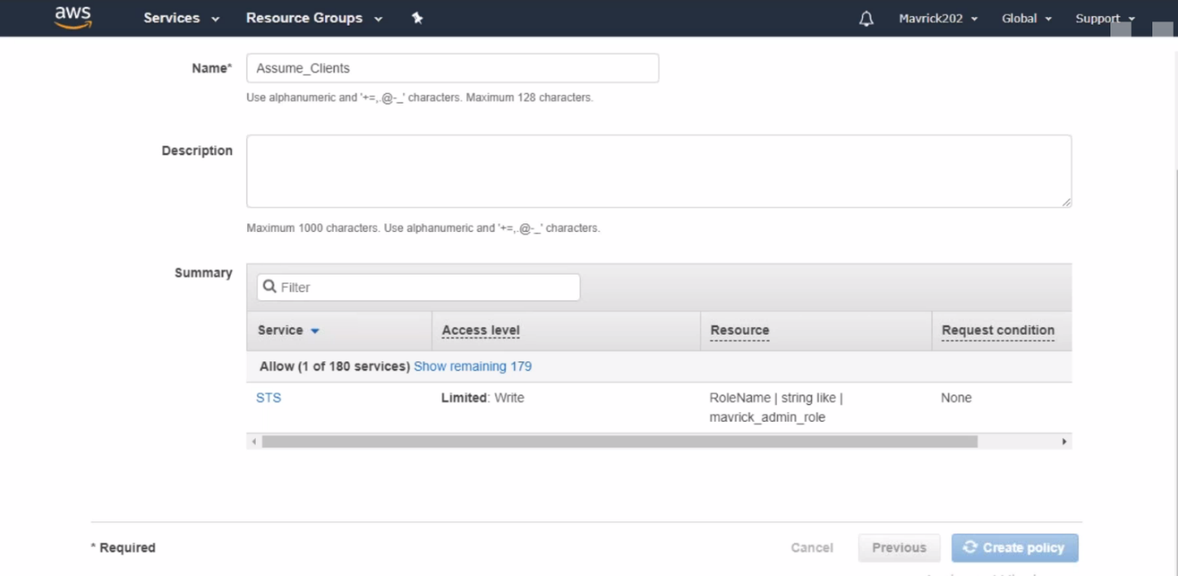

--- now the policy is created successfully and you have to add the policy to the group.

**Policy attaching to group**

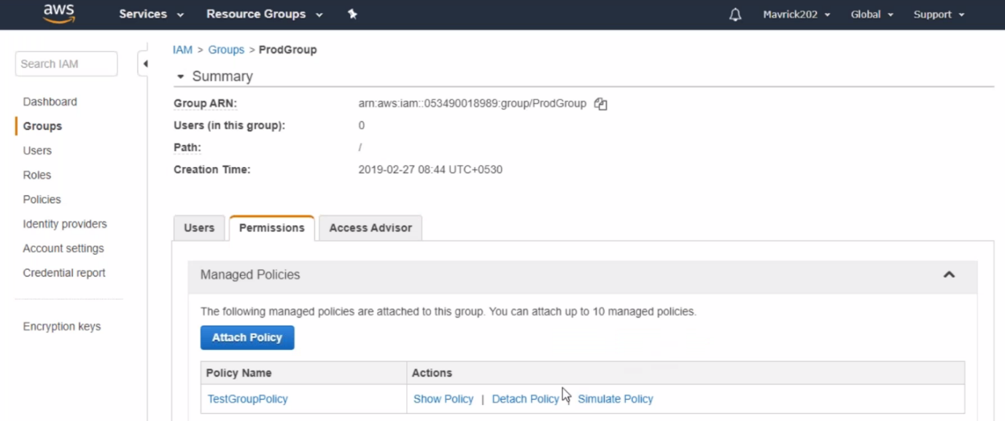

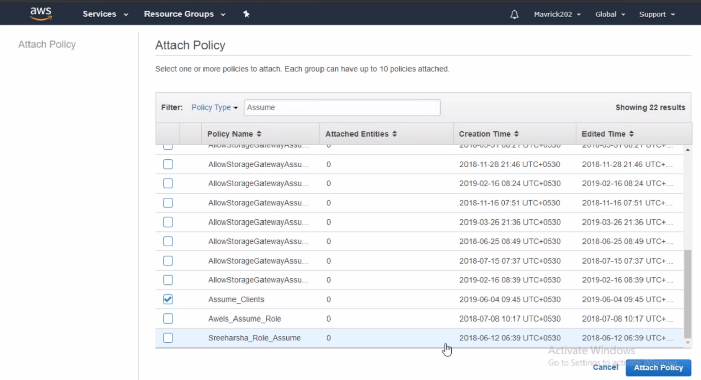

**Rohandheera AWS account**

here create admin role for another AWS account, Give EC2 full access.

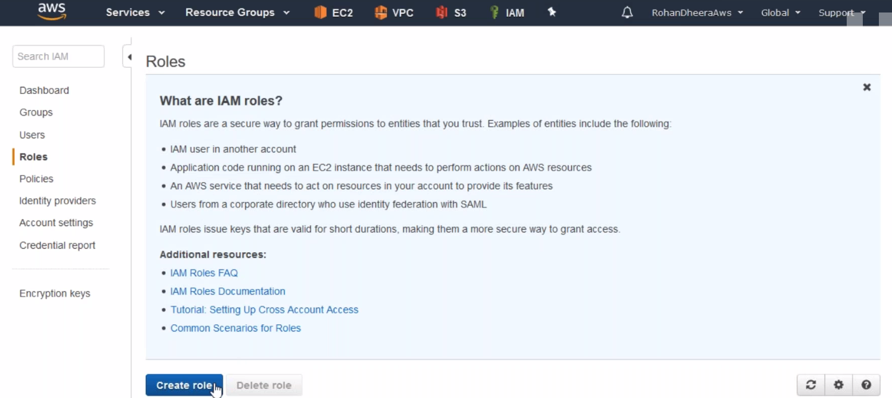

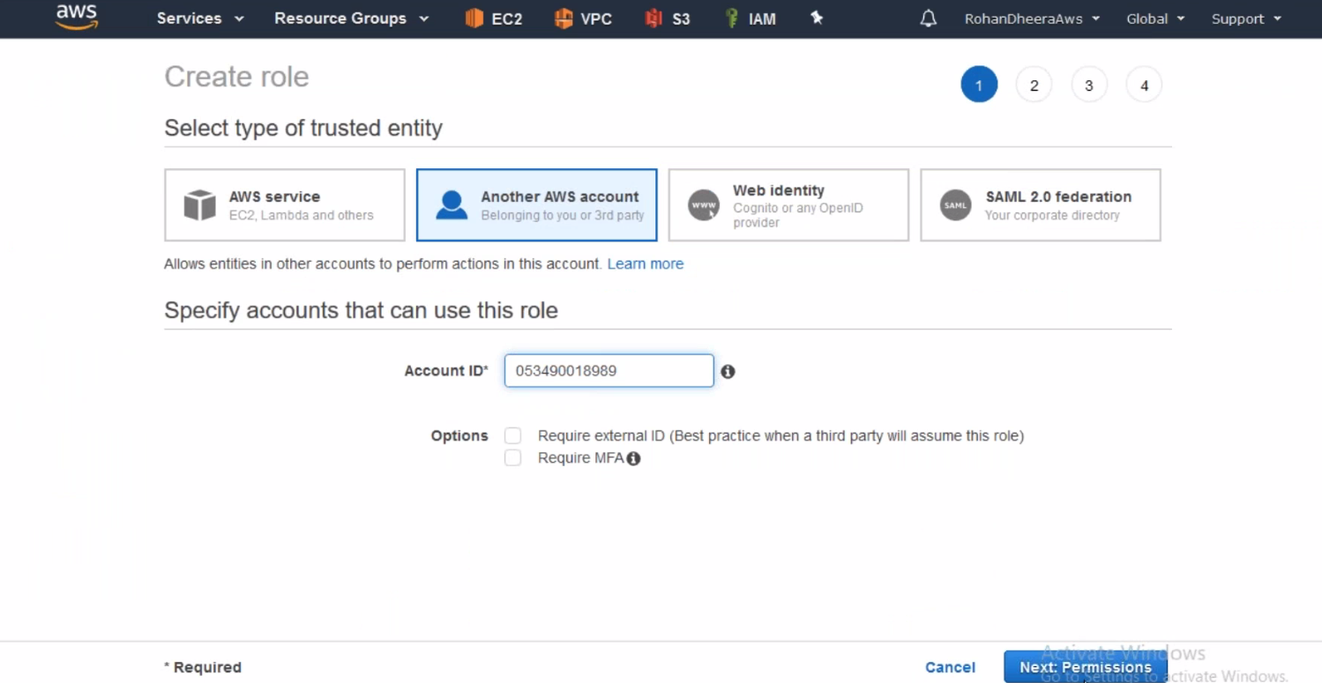

--- here give another account id from where you need to manage this account.

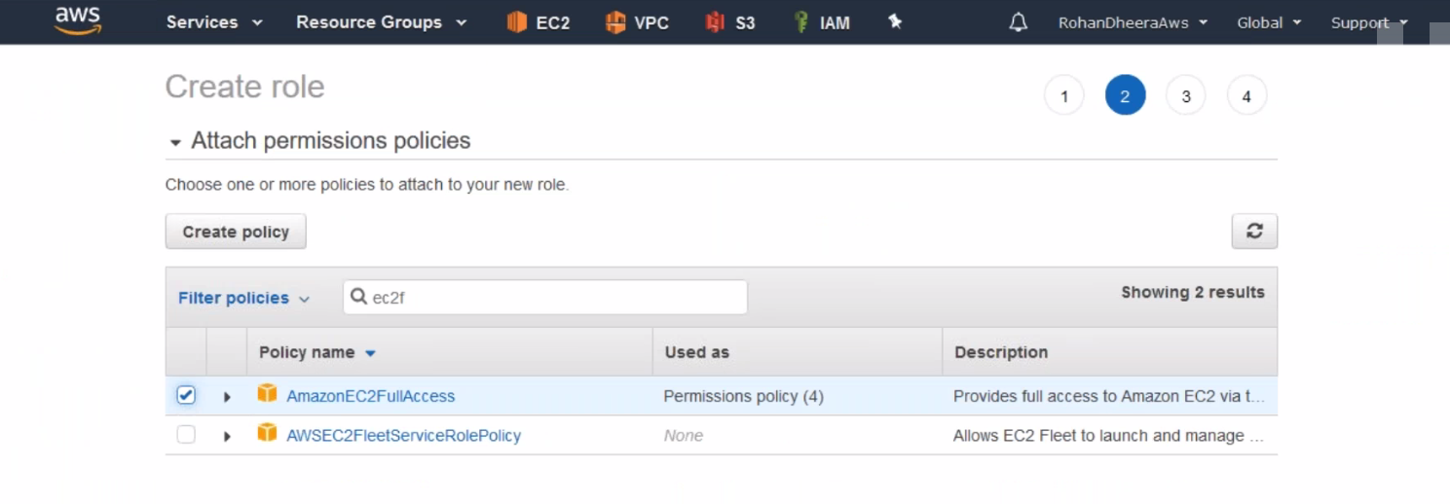

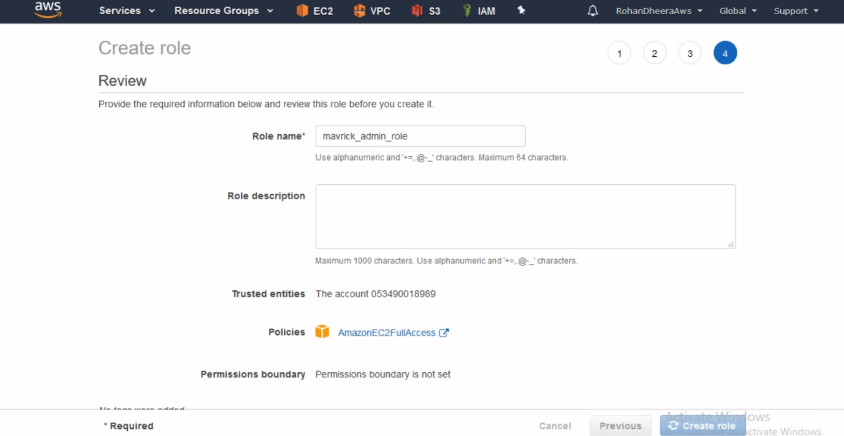

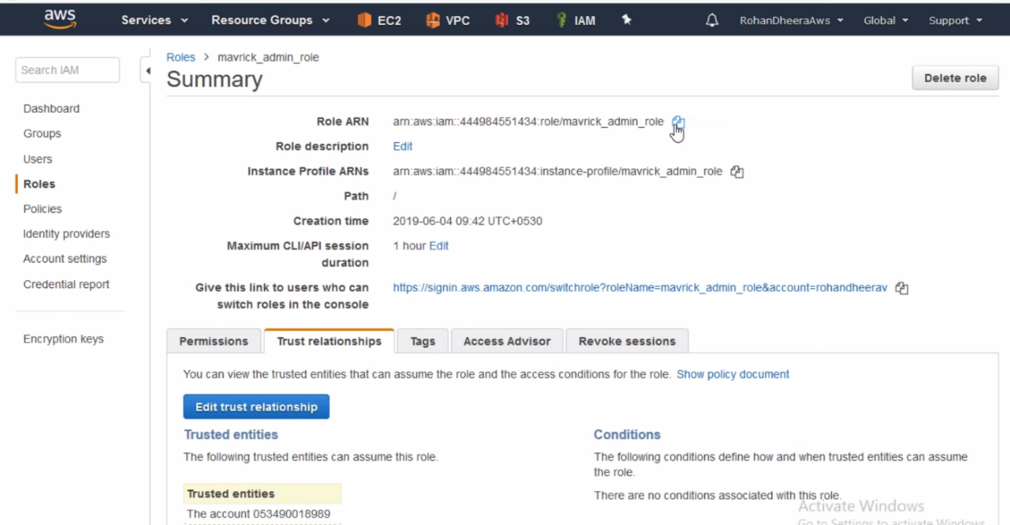

--- this role only trusts that account id and copy that ARN it will used in future purpose.

--- here we have successfully created role for another AWS account.